Controlling Temperature
in the last lab you built a system that can measure temperature. Now we move on to control. For this we need a transducer that can modify the temperature. In this case you will use a small heating element. This is basically a wire-wound resistor designed to withstand high temperatures without damage. When we run a current through the resistor it will start to warm up by Joule heating as it dissipates power P=VI=I²R.
In order to get the resistor hot we will need to dissipate significant power in the heater and thus will need to run significant current, far more than the 3 mA maximum that the LaunchPad can deliver to any pin.

Switching High Currents
Controlling significant currents from micro-controllers is a common enough function that there are a large number of single-chip solutions available. These generally contain high-current transistors to do the actual switching and then level-adjusting circuits that allow the 0-3.3V output signal of your LaunchPad to turn the switch on and off. Such drivers come in various different configurations and voltage/current ratings. Low side switches are the simples but require the load to float above ground. High-side switches allow the load to be connected to ground but are more complex internally and typically require two power sources. The fanciest switches are the half-bridges that combine a low-side and high-side switch into one unit. Two of these form a full-bridge which can drive current through a resistive load in both directions while needing only a single power supply.
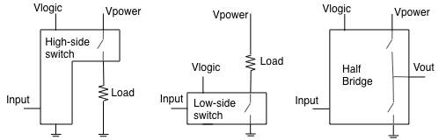Figure 1 Switch Geometries
The chip we will use is our old friend, the ULN2803 (Figure 2), which we last used used to drive an LED. This has eight identical low-side switches, each of which can carry up to 0.5A of current. This comes in an 18-pin package and is unusual in having no power supply pin. 16 of the pins carry signals into and out of the chip, one is the shared ground, and the last is connected to protection diodes that can be used when driving inductive loads such as motors. We want to switch currents up to at least 1A so should parallel at least four of the outputs. This splits the load current across the separate switches, reducing the heating of any one switch.
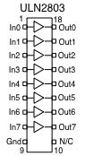Figure 2

Task 1
Add the extra components to your circuit to get the circuit of Figure 3 on the left. Tape the thermistor to the side of the heater so that they make good thermal contact. Remember that you must ground pin 9 of the ULN2803, even though there is no way to show this on the figure.
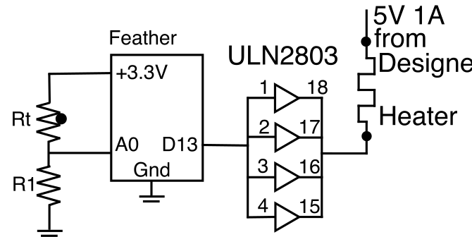
Figure 3

a) Write and run a program that will turn D13 on for 10 seconds and then off for 10 seconds, turning on and off the heater. All the time you should be printing out the temperature every 1 second Repeat forever. Paste your properly commented program below.
# Ben Kallus
# Turns on and off D13, prints the temperature as it goes

from board import *
from digitalio import DigitalInOut, Direction
from time import monotonic
from math import log
from analogio import AnalogIn

THERM_PIN = A0
OUTPUT_PIN = D13
R2 = 100000
R_INF = 0.1763
B = 3950

therm_pin = AnalogIn(THERM_PIN)
output_pin = DigitalInOut(OUTPUT_PIN)
output_pin.direction = Direction.OUTPUT

while True:
start = monotonic()
output_pin.value = not output_pin.value
print(f"Turning heater {'on' if output_pin.value else 'off'}")
counter = 1
while monotonic() - start < 10:
V = therm_pin.value / 65535 * 3.3
if V == 0:
V = 2 ** -100
R1 = -(V - 3.3) * R2 / V
print(f"Temperature:\t{B / log(R1 / R_INF) - 273}")
while monotonic() - start < counter:
pass
counter += 1

b) Plot the temperature as a function of time for one complete cycle. Paste your plot below and explain the shape.
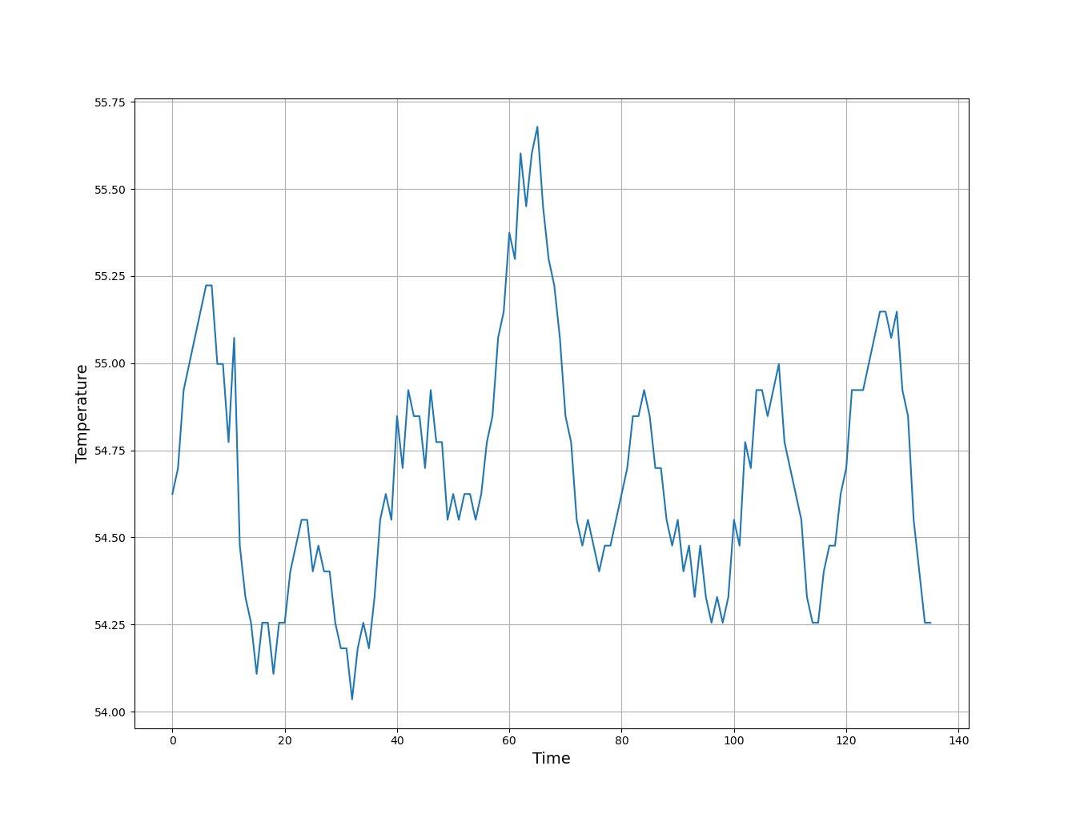
Shown above is a plot of the recorded temperature over 136 sec

Bang-Bang Control
Now that we can both measure temperature and generate heat, we are ready to control the temperature. The simplest control system has been in use since at least 1830 when Andrew Ure patented the bi-metallic thermostat. The algorithm is simple, if the temperature is too low, turn the heater on. If the temperature is too high, turn it off. Such a system, that is either fully-on or fully-off is called a Bang-Bang Control system, because it bangs back and forth between two states.
We think of any control system as a device to minimize the difference between a desired value and the current value. We call that difference the error of the system. The control system adjusts the value of its output, the response of the system, with the goal of minimizing the error. The bang-bang controller is simply the result of making the response into a binary output. Control systems were first studied by James Clerk Maxwell (of Maxwell's Equations fame) in the late 19th century as a way to improve speed control for steam engines. The field developed over the next half century to meet the needs of improving industry and for military uses, such as guiding torpedoes.

Task 2
Implement the bang-bang control algorithm to regulate the temperature of your heater/thermistor system at 50°C, about as hot as you can comfortably touch. You should make the set-point (the 50°C value) into a variable both for clarity of programming and to allow the value to be changed later. It will suffice to measure the temperature 2-10 times per second and to print it once per second.
a) Paste your commented, working, program below.
# Ben Kallus
# Tries to keep a heater at 50C.

from board import *
from digitalio import DigitalInOut, Direction
from time import monotonic
from math import log
from analogio import AnalogIn

THERM_PIN = A0
OUTPUT_PIN = D13
R2 = 100000
R_INF = 0.1763
B = 3950

therm_pin = AnalogIn(THERM_PIN)
output_pin = DigitalInOut(OUTPUT_PIN)
output_pin.direction = Direction.OUTPUT
output_pin.value = True

start_time = monotonic()

while True:
V = therm_pin.value / 65535 * 3.3
if V == 0:
V = 2 ** -100
R1 = -(V - 3.3) * R2 / V
temperature = B / log(R1 / R_INF) - 273
if monotonic() - start_time >= 1:
print(f"Temperature:\t{temperature}")
start_time = monotonic()
output_pin.value = temperature < 50

b) Plot the temperature as a function of time and paste your plot below.
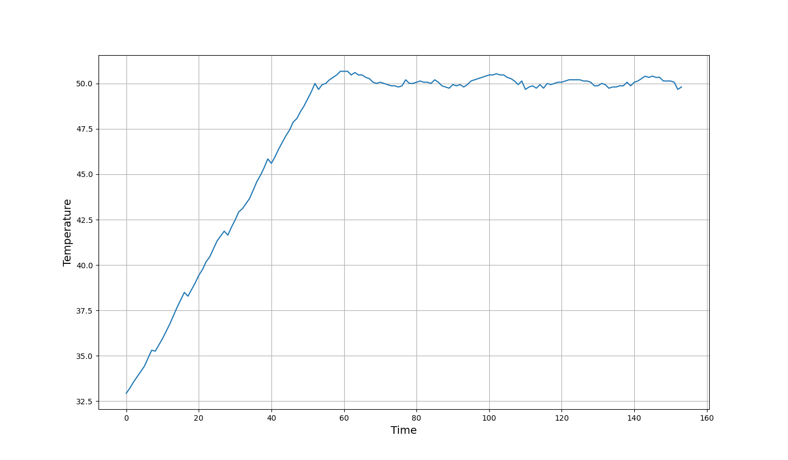

c) Discuss the shape of your plot and the accuracy/constancy of the final temperature.
The final accuracy was good; the temperature remained within 2 degrees of 50 for the entire time.

